**0.07:** Scroll a fake news page which is a bit more vivid / catches the eye more? I’ve watched the video a couple of times but it’s difficult to immediately understand that this is fake news related to corona (in the few short seconds we see the page).

EDIT: maybe just slow down the footage a bit, so people have time to read it.

Or take new screengrab from <https://www.altnews.in/topics/science/> or <https://leadstories.com/cgi-bin/mt/mt-search.cgi?search=&IncludeBlogs=1&blog_id=1&category=617&archive_type=Category&template_id=480&limit=20&page=4>

**0.12:** Preferably pick a less shocking image / keep it PG13 haha. Maybe just stick to the webpage of Statistica, or an EU report on fake news? (since the heading is “two thirds of europeans encounter fake news at least once a week) **- done**

**0.20:** Stay on the top of the screen longer (Coronavirus (COVID-19) Informationszentrum), instead of the grey screen at the bottom of that page. **- replaced, done**

**0.20-0.21**: I would change this to “**It** leads to a further erosion of confidence in real science and experts.” - is there any good footage of for instance Fauci we can use (as a symbol of legit scientist) **- done**

**1.04:** Keep the text “We use benchmark data from professional fact checkers to ensure our users’ content classification is reliable” on the screen a second longer - it’s hard to read all of this sentence within the time it’s on-screen at the moment. **- done**

**1.32-1.41**: snip together / fast forward different parts of algorithm running, starting from the part that’s already shown in the video, to end with the final view below (so it looks like the algorithm is running through all these steps sequentially, and the screen is “fuller” at the end): **- done**

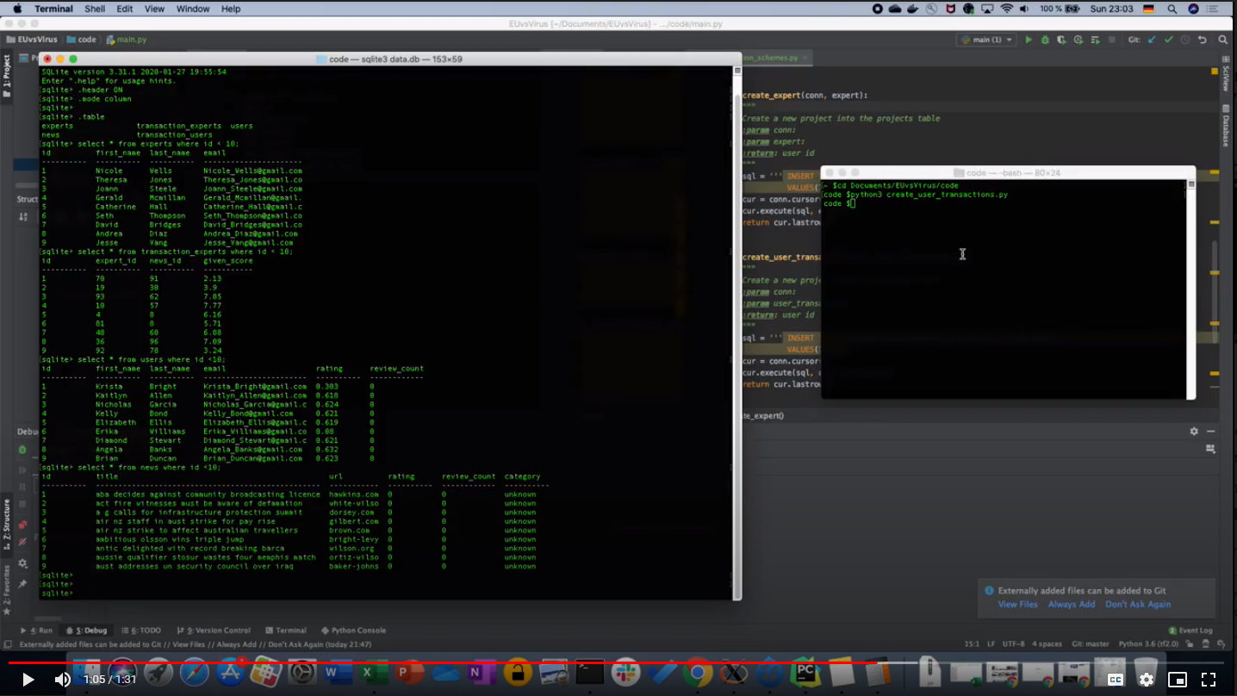

**1.49:** I’d say let’s change this to “In this crisis, millions of people are stuck at home, itching at an opportunity to help out.” **- done**

**1.53:** Let’s change this to: “Online fact-checking communities already exist. Our platform streamlines their efforts.” **- done**

**1.57-2.08:** “How can we keep the community engaged?” We’ll leave this out for now, until we have those pages running and can provide good footage. **- done**

**2.09:** [Accolades](https://docs.google.com/document/d/1D178-YGZq5VKkLNLAppT4eNQepqA5Pp2Iojie7TP0RQ/edit?usp=sharing) use these - perhaps a 1st prize badge / EUvsVirus hackathon logo and then show positive community feedback? (similar to the way a movie trailer shows positive reviews or prizes they won) **- done**

**2.15:** We’ll host on YouTube, so we can just add a link there (I think links also work in embedded YouTube videos?)

[FakeMash project page](https://devpost.com/software/community-driven-platform-for-identifying-fake-news)

Perhaps add this to the same “slide” as “Want to know more?” (so move “Want to know more?” up a bit, then let the link “FakeMash project page” appear underneath afterwards, after the viewer has read “Want to know more?”).

Overall suggestions from Jason: if we could somehow find music that is like the current v1 at the beginning and then turns to 'epic' style of music when we transition to explaining our solution so that our work has a soundtrack that sounds super triumphant and full of hope.